Chapter 4, Problem 79.

Obtain the Thevenin equivalent of the circuit in Fig. 4.123 using PSpice.

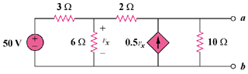

Figure 4.123
For Prob. 4.79.

